**Defect Tracker System requirements documentation – Team B**

**1. Use cases and User scenarios**

1. Employee registration

* Actor – Admin
* Admin can register a new employee in the system.
* Fields:

|  |
| --- |
| **Employee id String**  First name - String  Last name - String  Password - String  Email - String  Phone number - String  Address - String  Designation - String  Gender - String  NIC - String  Join Date - Date  DOB – Date |

1. Login

* Actors:
  + Admin
  + QA
  + Developer
* User can login only using valid employee id and password
* User can’t login using invalid employee id or password
* Fields:

|  |
| --- |
| **Employee id - String**  Password - String |

1. Create Project

* Actor – Admin
* Admin can create new project.
  + Admin can assign members to the project
* Fields:

|  |
| --- |
| **Project ID - String**  Name - String  Start date - Date  End Date - Date  Description – String  Team members – String |

1. Manage Project

* Admin can view, edit, and delete projects.
  + Admin can add and remove members of a project.
* QA, Developer cannot edit and delete projects
  + Since the QA/ developer cannot edit the project, they cannot add and remove members to the project

1. Submit Defect

* Actor – QA
* QA can track defect

Fields:

|  |
| --- |
| **Defect ID - String**  Name - String  Description - String  Recreate id - String  Expected output - File  Priority - String  Severity - String  Status - String  Reporter - String  Created on – Date  Module id - String |

|  |
| --- |
| **Recreate id - String**  Steps – String  Add Screenshot - File |

* QA can review, edit & delete the defect
* QA can assign a defect to a developer
* After a defect being assigned to a developer QA can't edit or delete the defect
* Only QA can reopen & close the defect
* QA can view release notes.

1. Receive notification

* Developer will receive a notification after being assigned to a defect
* QA will receive a notification after the status of the defect being changed to fixed

1. Change status

* Developer can view defects
* Developer can change the status of a defect

1. Upload release note

* Actor – Developer
* Developer can upload release notes
* Fields:

|  |
| --- |
| Release Id - String  Release version – String  Upload file – File |

1. Add modules

* Developer can add modules
* Fields:

|  |
| --- |
| Module Id – String  Name – String  Assigned to – String |

**2. User Interfaces**

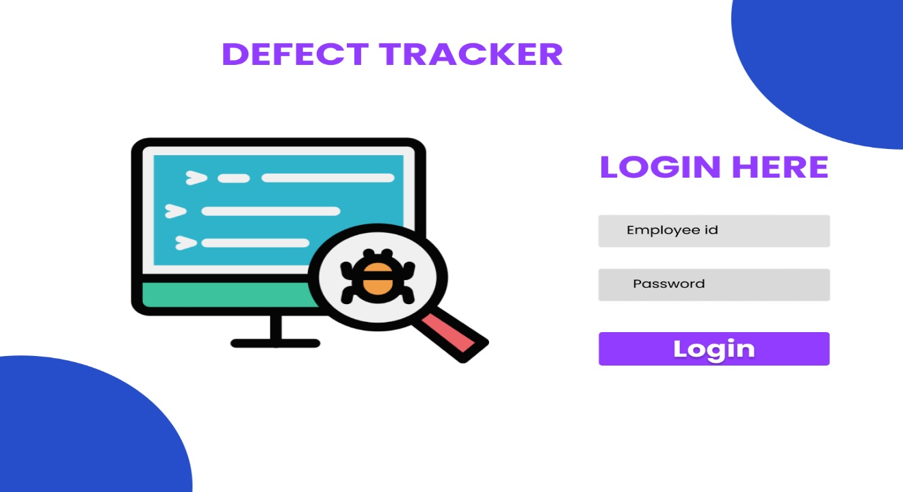**1. User log in page**

**2. Dash board**

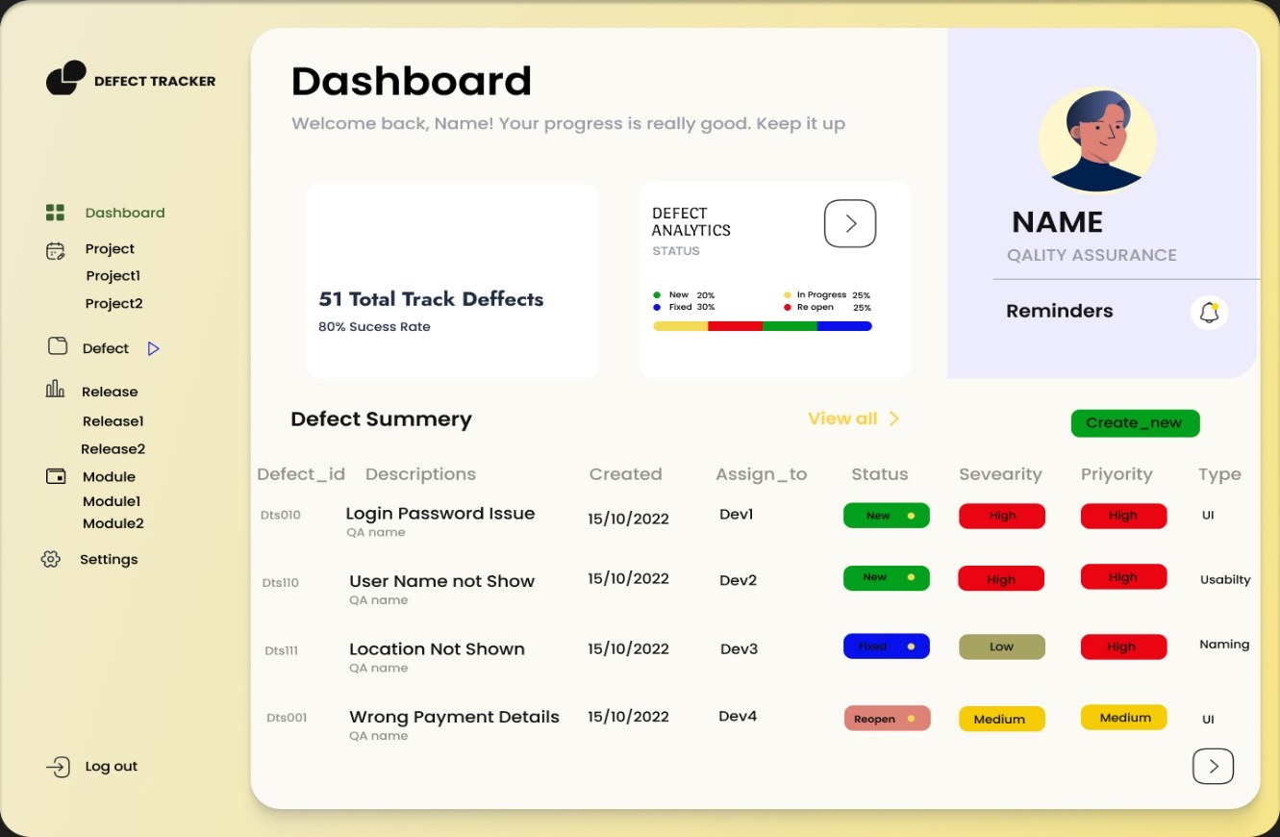

3. Registration page

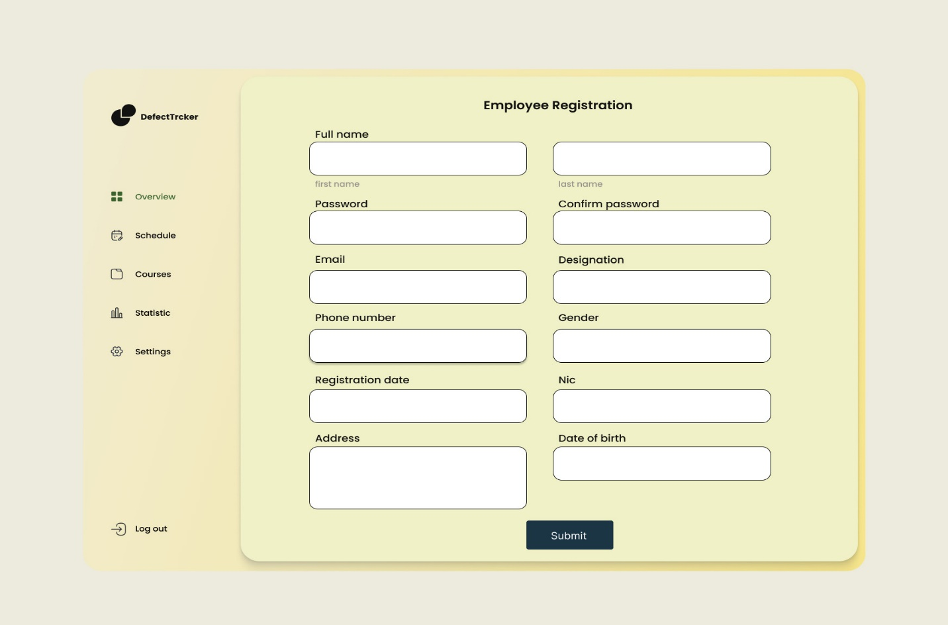

1. Track Defect

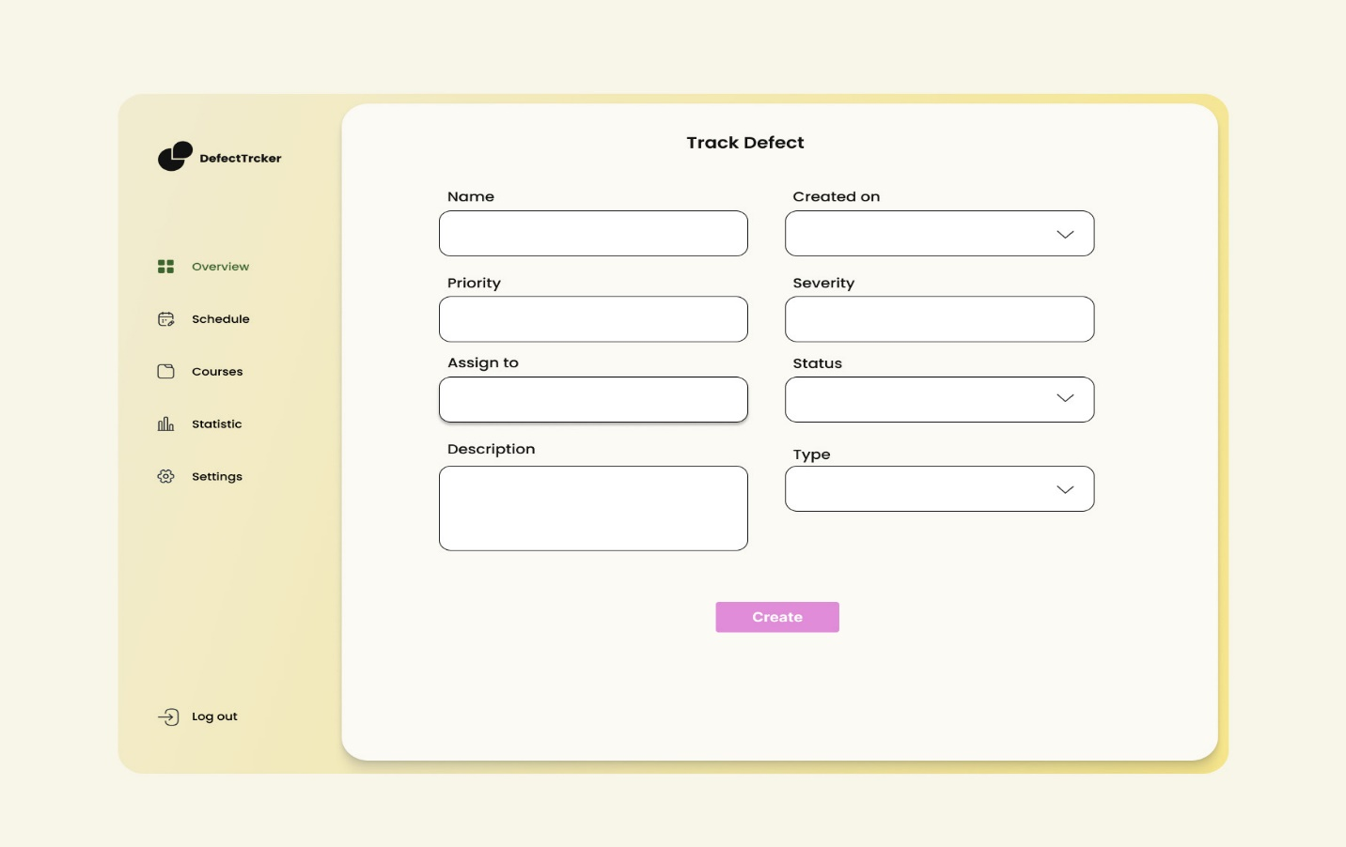

5. Create Project

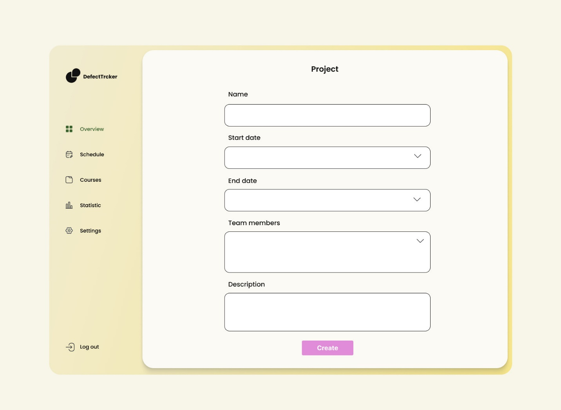

**3. Work flow diagram for status**

QA adds a defect

Developer views the defect

QA tests the defect

QA reviews the defect

1. 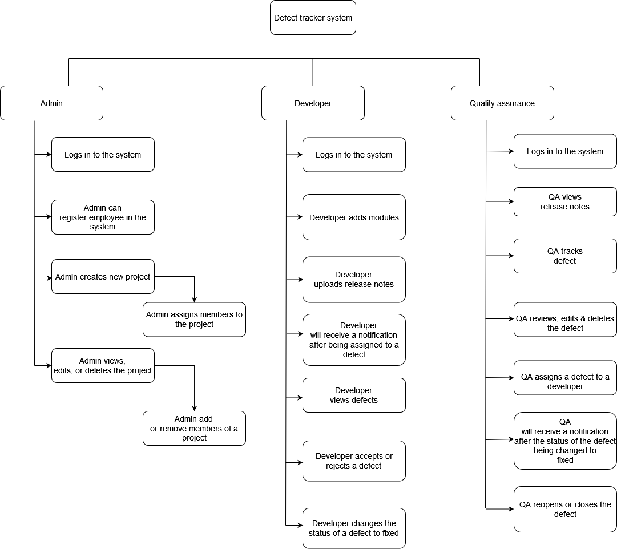**Work flow of the system**